The EMERGE Lab
Relevant Logos
EMERGE  Wire Seahorse Black | 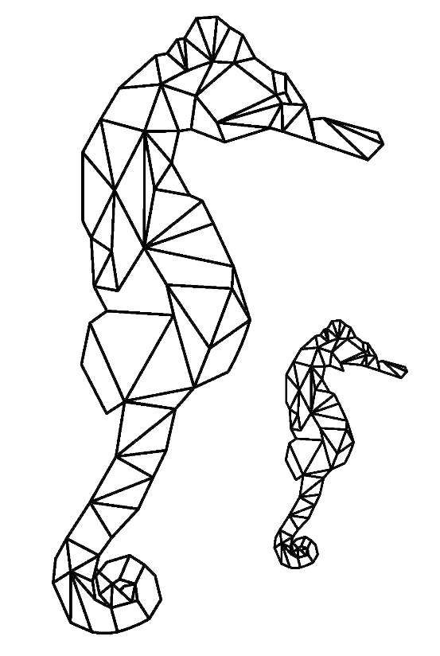
EMERGE  Wire Seahorse  White | 
University of Southern California Logo
USC  Logo  White | 
USC  Logo  Yellow | 

